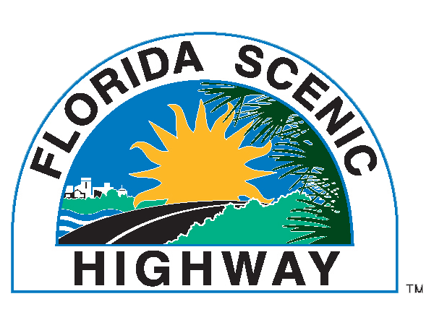

Florida Scenic Highways Program
Fact Sheet

The Florida Scenic Highways Program was developed in response to legislation (Section 335.093, Florida Statutes, 1995) “to preserve, maintain, protect and enhance Florida’s outstanding cultural, historical, archeological, recreational, natural and scenic resources.” It is a “Grass Roots” program driven by local communities and the citizens of the state.
- FSHP is soon to celebrate it’s 20 year anniversary
- There are a total of 24 designated Scenic Highways in Florida
- The Florida Keys Scenic Highway has been designated an All-American Road, the highest scenic road designation in the country. In addition, Florida is home to five (5) National Scenic Byways: A1A Scenic & Historic Coastal Byway, Big Bend National Scenic Byway, Florida Black Bear National Scenic Byway, Indian River Lagoon National Scenic Byway, and Ormond Scenic Loop & Trail

- Florida’s Scenic Highways account for over 1,400 miles of roadway traveling through 29 counties

- Since 1998 $30,000,000+ in federal, state and local grant funding has been awarded to Florida’s Scenic Highways.

- Five (5) benefits of Scenic Highway designation are 1) resource protection; 2) community recognition; 3) economic development/tourism; 4) community visioning; and, 5) partnering. In addition, a 2010 study conducted by the University of Minnesota noted the following economic impacts of Scenic Byway designation:
  - 19 - 33 jobs are created per $1 million of visitor spending
  - 3.4% - 20% increase in annual traffic
  - $0.045-$0.08 State & Local tax receipts per $1 visitor spending
  - $65,000 extra visitor spending with 1% increase in vehicle miles traveled (VMT)
  - $104 visitor group spending per trip
  - $32,500 annual visitor spending per mile
- Every FDOT District has at least 1 designated byway
- 3 new groups are currently working towards designation

